Web data extraction Requirement document

Suggested Code Policy:

1. Copy the Project folder structure from bellow github link.

<https://github.com/hackathonScrapping/BANK.git>

1. Use Python(Mandatory) with BeautifulSoup, Scrapy and Selenium (Feel free to use any other Python libraries)
2. Store Scrapped data with provided file name and CSV format.

Work 1:

**Scarped Data Format (File Name - Llyods_Data_Deposit_<YYYY_MM_DD>.csv)**

|  |  |  |  |  |  |  |  |  |  |
| --- | --- | --- | --- | --- | --- | --- | --- | --- | --- |
| Date | Bank Name | Product Type | Product Name | Bank Offer | Account  Opening Balance | Minimum  Balance | Maximum Balance | Rate % | AER % |
|  |  | Offline |  |  |  |  |  |  |  |
|  |  |  |  |  |  |  |  |  |  |
|  |  |  |  |  |  |  |  |  |  |
|  |  |  |  |  |  |  |  |  |  |
|  |  |  |  |  |  |  |  |  |  |
|  |  |  |  |  |  |  |  |  |  |

**Savings Account – PDF**

[**https://www.lloydsbank.com/current-accounts/all-accounts.asp**](https://www.lloydsbank.com/current-accounts/all-accounts.asp)

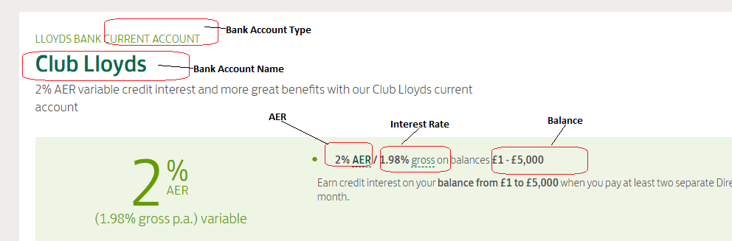

Work 2: Mortgage Rates

|  |  |  |  |  |  |  |  |  |  |
| --- | --- | --- | --- | --- | --- | --- | --- | --- | --- |
| Date | Bank Name | Product Type | Product Name | Loan amount | Mortgage Amount | Interest Tenor | Interest type | Rate % | APRC % |
|  |  | Offline |  |  |  |  |  |  |  |
|  |  |  |  |  |  |  |  |  |  |
|  |  |  |  |  |  |  |  |  |  |
|  |  |  |  |  |  |  |  |  |  |
|  |  |  |  |  |  |  |  |  |  |
|  |  |  |  |  |  |  |  |  |  |

<https://www.lloydsbank.com/mortgages/mortgage-calculator.asp>

Case 1: Property Value: 72,160; Your deposit: 14432

Case 2: Property Value: 216,480; Your deposit: 43296

Case 2: Property Value: 360,800; Your deposit: 72160

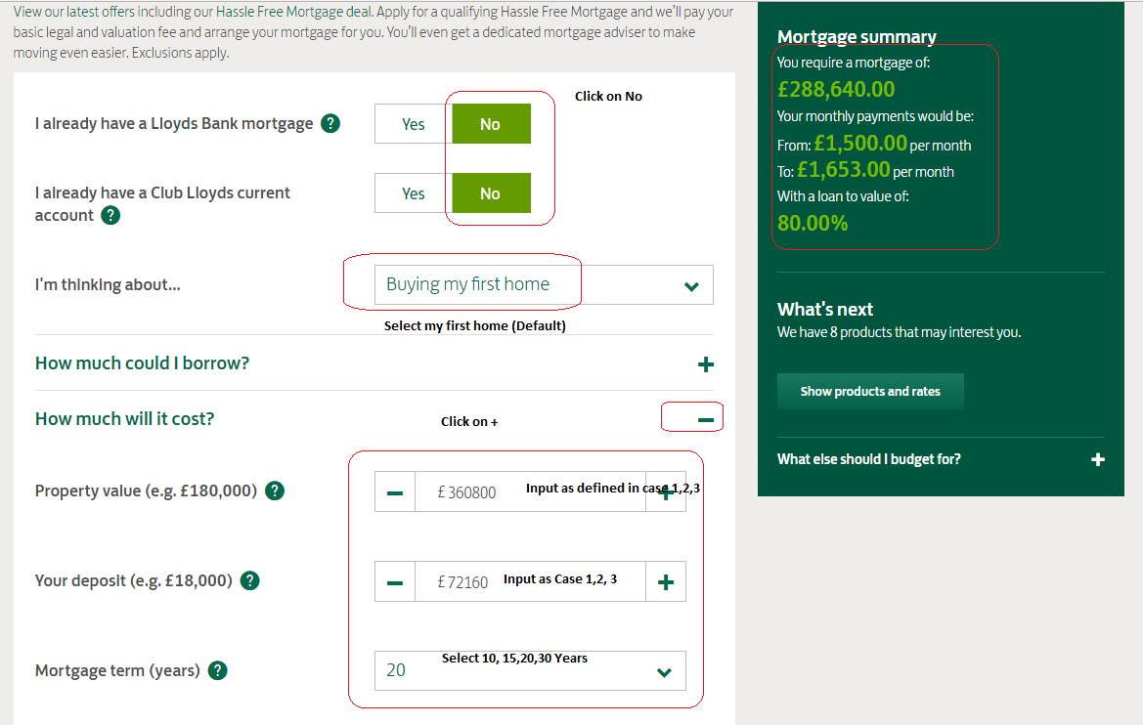

Click on Show products and rates

<https://www.lloydsbank.com/mortgages/mortgage-calculator.asp#p:results>

